Task 1 – Lead Form to Automatic Welcome Email
Google Forms → Gmail Automation
Objective: Automatically send a welcome/thank-you email to a lead after they submit the digital marketing enquiry form.

1. Automation Workflow
The workflow connects Google Forms with Gmail through Zapier. Whenever a new form response is received, Zapier triggers an automated welcome/thank-you email to the email address submitted by the lead.

2. Trigger – New Form Response
Trigger app: Google Forms
Trigger event: New Form Response
The trigger captures the submitted lead details, including name, email address, phone number, service interest, budget, marketing challenge, start timeline, and requirements.

3. Action – Send Email
Action app: Gmail
Action event: Send Email
The lead's submitted email address is used as the recipient, and Zapier sends an automated thank-you/welcome message confirming that the enquiry has been received.

4. Test Result
The Zapier workflow was tested successfully. A new Google Forms response triggered the Gmail action, and the welcome/thank-you email was received successfully.

5. Business Usefulness
This automation provides an immediate response to new leads without requiring manual email sending. It improves response time, confirms that the enquiry was received, and helps maintain a professional communication process.

6. Screenshots / Evidence
1. Zapier Task History – Successful Automation Run
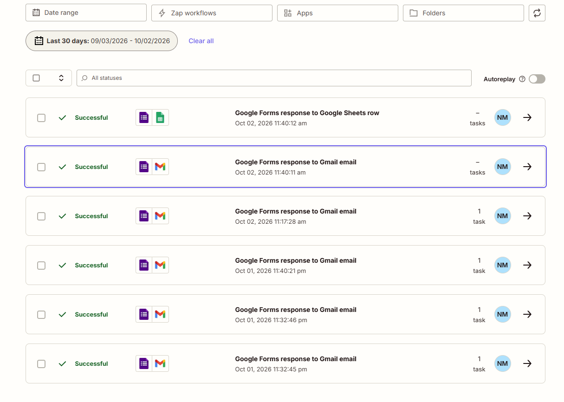
2. Zapier Workflow – Google Forms to Gmail
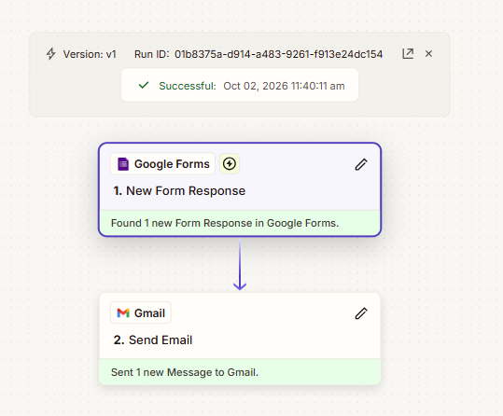
3. Google Forms Trigger – New Form Response
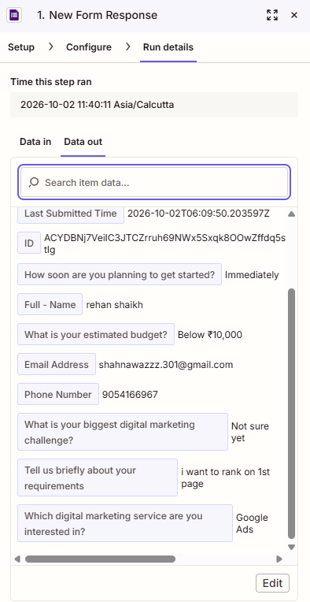
4. Automatic Welcome / Thank-You Email
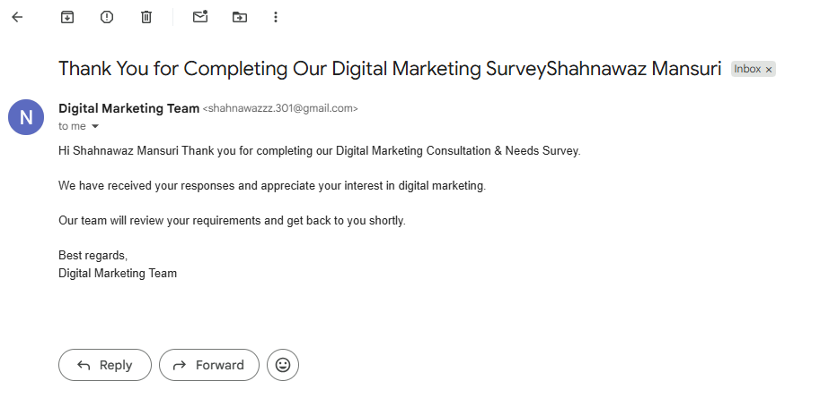

7. Submission Checklist
- Zapier workflow screenshot
- Trigger screenshot
- Action screenshot
- Successful test result screenshot
- 2–3 line business usefulness explanation

